**School of Mechanical and Aerospace Engineering**

**MA4832 Microprocessor Systems**

**Hands On Project (Preparation)**

**9 Nov 2020**

In order to undertake the hands-on project on 9 Nov 2020, student groups of 3 members are to assemble a hardware board (figure1) that will be used with the TM4C123G launch pad for the hands on project (HoP).

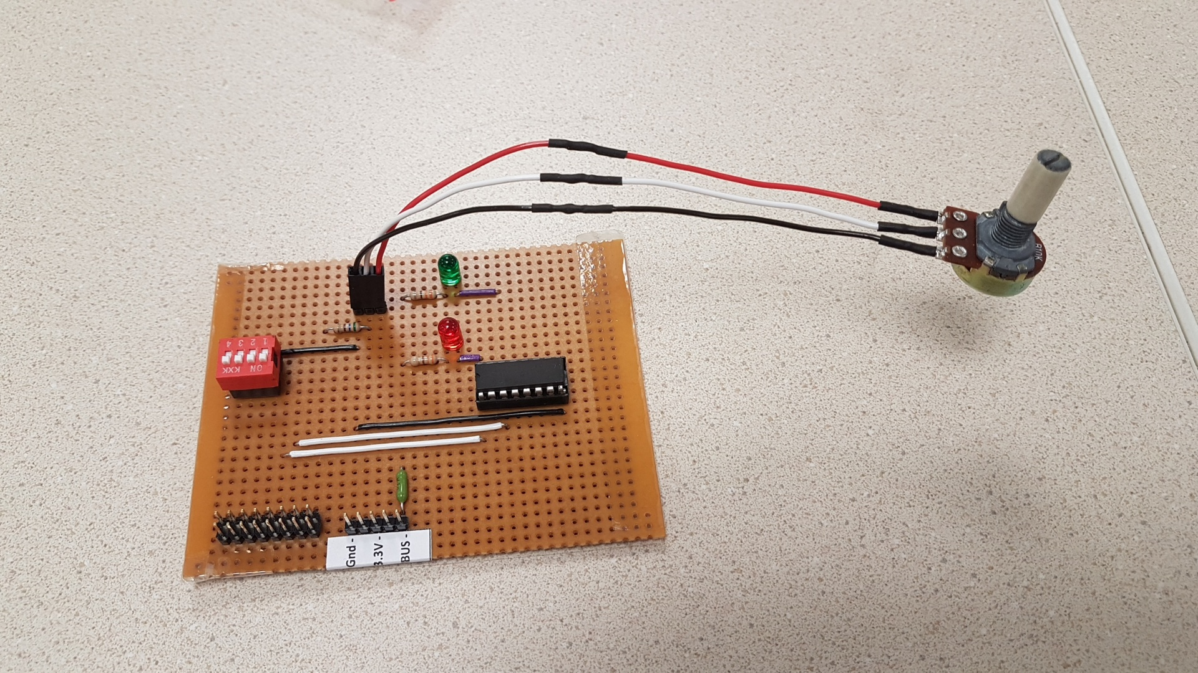

Figure 1

A mark component of 40% of the total HoP grade will go towards the quality of manufacture and assembly of the board.

**Grading of the quality of assembly of the hardware board will be in the following areas.**

* All components are to sit squarely on the strip board. LEDs, plug pins and IC sockets to sit squarely on the circuit board.
* All wires are to be kept as straight as possible.
* Ensure that when soldering wires to the board, that they are not overheated to the point that the wire insulation shrinks and exposes the bare wire.
* Solder joints to potentiometer and wire extensions are to be covered with heat shrink (figure 2). Wire lengths are to be kept the same. Take care for any exposed wire not properly covered by the heat shrink. Ensure that the heat shrink is properly and evenly shrunk and covers all exposed areas of the wire and solder joint.
* Component wires are to be neatly terminated and trimmed.
* Soldering on each pad to be kept neat (prevent solder flow to adjacent track). Trim all wires neatly. Solder to show even adhesion around each solder pad. (figure 3)

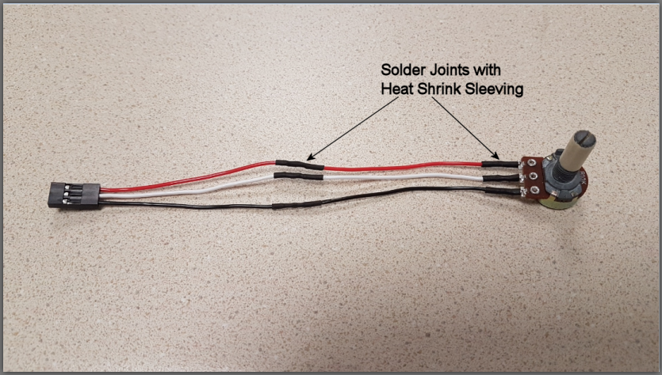

Figure 2

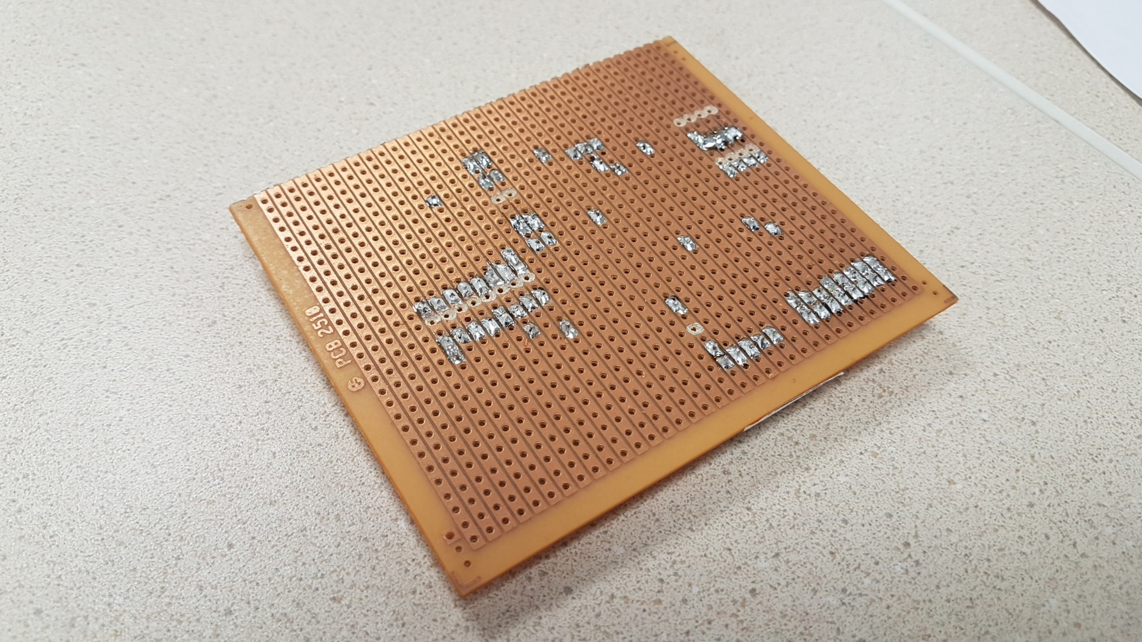

Figure 3.

The wiring diagram of the hardware board is shown in figure 4. Follow the wiring and component placement exactly when manufacturing the board.

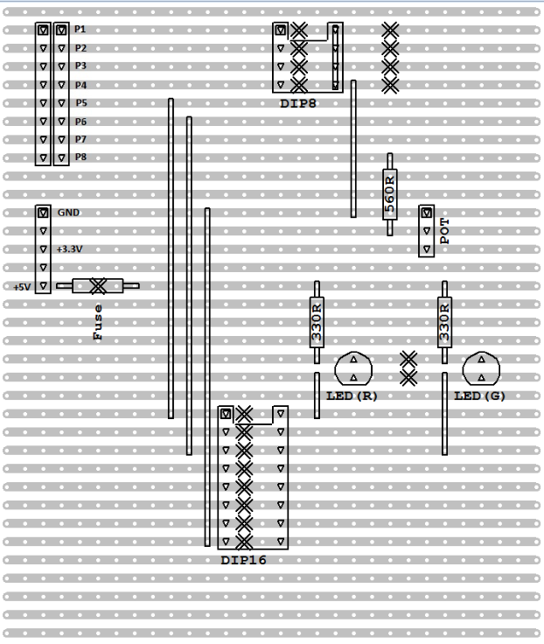

Figure 4

Please go to the Mechatronics lab to draw the components to manufacture the board and register your group members.

Please book a time slot for use of the soldering station at the Mechatronics Lab.

(2 slots available a day during the month of Oct 2020)

* 9.30am to 11.30am
* 1.30pm to 3.30pm

All assembled hardware boards must be ready for HoP by Mon 9 Nov 2020.